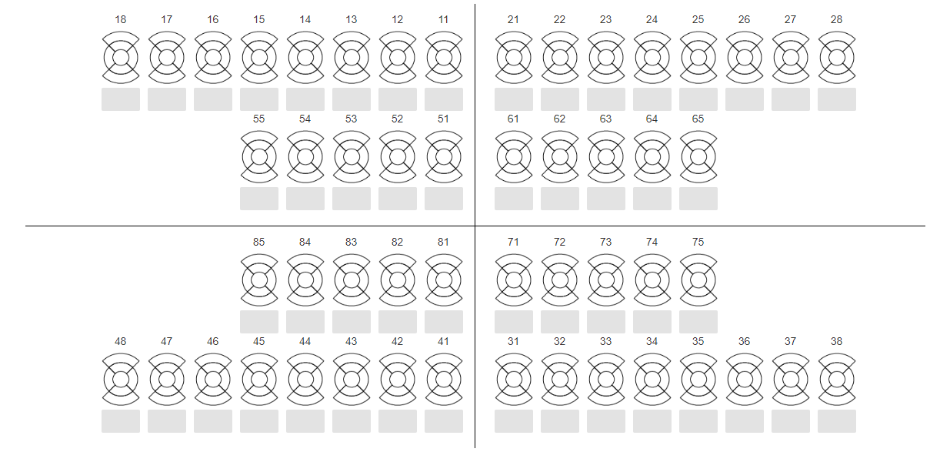**ODONTOGRAMA DIAGNÓSTICO**

|  |  |  |  |  |
| --- | --- | --- | --- | --- |
| 18  17  16  15  14  13  12  11 | _____________________________________ |  | 28 | _____________________________________ |
| 17 | __________________________________ |  | 27 | __________________________________ |
| 16 | __________________________________ |  | 26 | __________________________________ |
| 15 | __________________________________ |  | 25 | __________________________________ |
| 14 | __________________________________ |  | 24 | __________________________________ |
| 13 | __________________________________ |  | 23 | __________________________________ |
| 12 | __________________________________ |  | 22 | __________________________________ |
| 11 | __________________________________ |  | 21 | __________________________________ |

|  |  |  |  |  |
| --- | --- | --- | --- | --- |
| 48  17  16  15  14  13  12  11 | _____________________________________ |  | 38 | _____________________________________ |
| 47 | ______________________________________________ |  | 37 | ______________________________________________ |
| 46 | ______________________________________________ |  | 36 | ______________________________________________ |
| 45 | ______________________________________________ |  | 35 | ______________________________________________ |
| 44 | ______________________________________________ |  | 34 | ______________________________________________ |
| 43 | ______________________________________________ |  | 33 | ______________________________________________ |
| 42 | ______________________________________________ |  | 32 | ______________________________________________ |
| 41 | ______________________________________________ |  | 31 | ______________________________________________ |

|  |  |  |  |  |  |  |  |  |  |  |  |  |  |
| --- | --- | --- | --- | --- | --- | --- | --- | --- | --- | --- | --- | --- | --- |
| 0 | Sano | | |  | 5 | | Perdido por cualquier otro motivo |  | T | Traumatismo (fractura) |  | 14 | Bolsas periodontales |
| 1  17  16  15  14  13  12  11 | Con caries | | |  | 6 | | Fisura obturada |  | 9 | No registrado |  | 15 | Fluorosis |
| 2 | Obturado con caries | | |  | 7 | | Soporte de puente, corona, funda o implante |  | 11 | Recesión gingival |  | 16 | Alteraciones de forma, número, tamaño, textura, posición |
| 3 | Obturado sin caries | | |  | 8 | | Diente sin erupcionar |  | 12 | Tratamiento de conductos |  | 17 | Lesión endoperiodontal |
| 4 | Perdido como resultado por caries | | |  |  | |  |  | 13 | Instrumento separado en un conducto |  |  |  |
|  | |  |  | | |
|  | |  |  | | |
|  | |  |  | | |
|  | |  |  | | |

**ODONTOGRAMA DE EVOLUCIÓN**

***TRATAMIENTOS RELIZADOS***

|  |  |  |  |  |
| --- | --- | --- | --- | --- |
| 18  17  16  15  14  13  12  11 | _____________________________________ |  | 28 | _____________________________________ |
| 17 | __________________________________ |  | 27 | __________________________________ |
| 16 | __________________________________ |  | 26 | __________________________________ |
| 15 | __________________________________ |  | 25 | __________________________________ |
| 14 | __________________________________ |  | 24 | __________________________________ |
| 13 | __________________________________ |  | 23 | __________________________________ |
| 12 | __________________________________ |  | 22 | __________________________________ |
| 11 | __________________________________ |  | 21 | __________________________________ |

|  |  |  |  |  |
| --- | --- | --- | --- | --- |
| 48  17  16  15  14  13  12  11 | _____________________________________ |  | 38 | _____________________________________ |
| 47 | ______________________________________________ |  | 37 | ______________________________________________ |
| 46 | ______________________________________________ |  | 36 | ______________________________________________ |
| 45 | ______________________________________________ |  | 35 | ______________________________________________ |
| 44 | ______________________________________________ |  | 34 | ______________________________________________ |
| 43 | ______________________________________________ |  | 33 | ______________________________________________ |
| 42 | ______________________________________________ |  | 32 | ______________________________________________ |
| 41 | ______________________________________________ |  | 31 | ______________________________________________ |